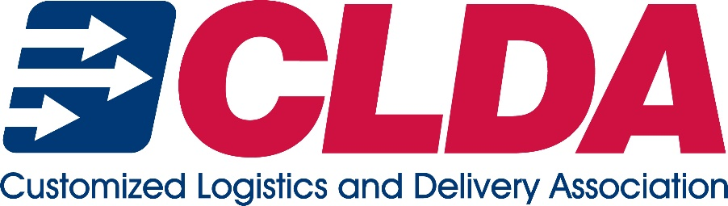
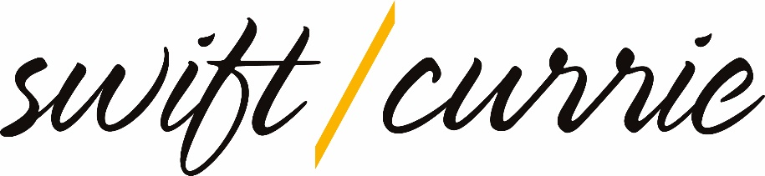

Disclaimer:
The attached are intended to serve only as sample templates. CLDA recommends conferring with legal counsel to tailor these templates to your specific organization and the laws of your state. CLDA has partnered with the attorneys at Swift, Currie, McGhee, & Hiers, LLP to arrange for a discounted review of these sample documents.
By providing these documents, neither CLDA nor Swift, Currie, McGhee & Hiers, LLP is offering legal advice. Similarly, no duties are intended or created by this communication. If you do not have a signed fee contract or engagement letter with Swift, Currie, McGhee & Hiers, LLP, the firm does NOT represent you as your attorney.​
To schedule a consultation and review in order to tailor these documents to your organization, you may reach out to Cristine Huffine, at Cristine.huffine@swiftcurrie.com or Crystal McElrath, at crystal.mcelrath@swiftcurrie.com

CONFIDENTIALITY & NON-DISCLOSURE AGREEMENT

EMPLOYEE acknowledges and agrees that during the performance of her duties under this Agreement she will have access or learn information regarding COMPANY customers or business associates, as well as confidential or proprietary information relating to COMPANY’s corporate strategic alliances, clients, technologies, legal matters, trade secrets, sales, financial matters, sensitive employee information, and other business matters (collectively “Confidential Information”). EMPLOYEE acknowledges and agrees that all such Confidential Information is and will remain the exclusive property of COMPANY and that such Confidential Information is of great economic value to COMPANY. During the term of this Agreement and thereafter, EMPLOYEE will not, directly or indirectly, divulge or disclose any Confidential Information to any person, firm, association or company except (i) as permitted by the expressed terms of the Agreement to carry out the purposes for which the information was disclosed and (ii) in accordance with applicable law. Improper use of disclosure of this Confidential Information may result in disciplinary action up to an including termination of employment and possible legal action

Nothing in this Agreement prevents Employee from communicating with, filing a charge or complaint with, providing documents or information voluntarily or in response to a subpoena or other information request to, or from participating in an investigation or proceeding conducted by the Equal Employment Opportunity Commission, National Labor Relations Board, the Securities and Exchange Commission, law enforcement, or any other any federal, state or local agency charged with the enforcement of any laws, or from responding to a subpoena or discovery request in court litigation or arbitration; or limits Employee from exercising rights, if any, under Section 7 of the NLRA or similar state law to engage in protected, concerted activity with other employees

EMPLOYEE acknowledges acceptance of this Agreement by her signature below:

________________ __________________________________
Date NAME

Agreed to and accepted on behalf of COMPANY:

___________________ By:______________________________
Date Its: ______________________________
3990258v.1
4846-8508-6430, v. 1

